**GOOD SAMARITAN 5K Race starts: 7:00am, August 31, 2014**

**DIRECTIONS**: START at ANDREWS CHURCH, Go East (UP) along HOPE ROAD to TGIF; turn RIGHT onto LADY MUSGRAVE ROAD; go past EDEN GARDENS, (Do not turn onto Trafalgar Road here); go past SPARTAN HEALTH CLUB to NCB TOWERS; turn RIGHT onto OXFORD ROAD; head towards EMANCIPATION PARK; turn RIGHT onto KNUTSFORD BOULEVARD; go past JPS; turn LEFT onto TRAFALGAR Road; to ABBEY COURT APTS; turn right onto HOPE ROAD; go past ANDREWS MEMORIAL HOSPITAL; enter the ANDREWS CHURCH. [5.9kilometres/3.7miles]

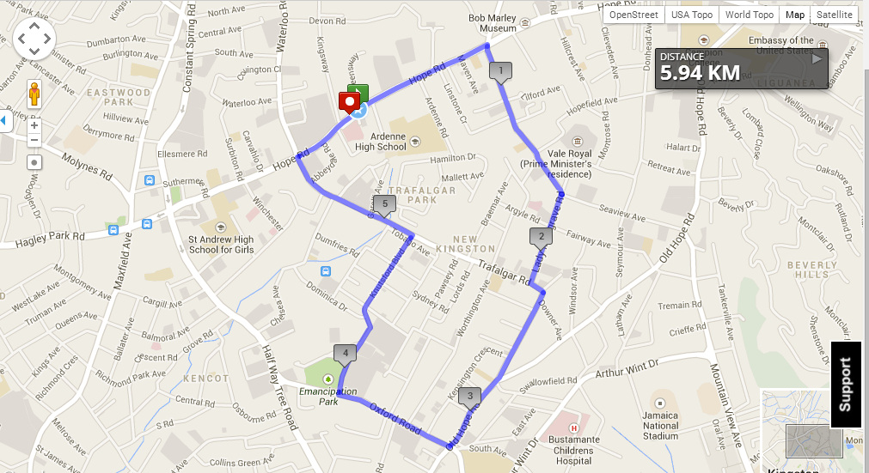**ROUTE**

**MAP**

The **GOOD SAMARITAN 5K** is a run/walk event to promote health and wellness for all persons, while raising funds to support the **Good Samaritan Foundation**, centre for homeless persons at Heroes Circle, Kingston, Jamaica. The event is organized by the Health Ministries Department of the Andrews SDA Church, as part of its annual outreach.  
For more information and Registration Forms, visit **www.andrewsmemorialsdachurch/events**